Poverty Infant Mort White Crime Doctors \

labels

0 10.670370 6.114815 83.114815 342.962963 291.007407

1 15.152174 7.669565 80.608696 483.217391 224.200000

Traf Deaths University Unemployed Income count

labels

0 1.166667 30.059259 4.992593 57441.888889 27

1 1.683478 23.278261 5.595652 45579.304348 23

Index(['Alaska', 'California', 'Colorado', 'Connecticut', 'Delaware', 'Hawaii',

'Illinois', 'Iowa', 'Kansas', 'Maine', 'Maryland', 'Massachusetts',

'Minnesota', 'Nebraska', 'New Hampshire', 'New Jersey', 'New York',

'North Dakota', 'Oregon', 'Pennsylvania', 'Rhode Island', 'Utah',

'Vermont', 'Virginia', 'Washington', 'Wisconsin', 'Wyoming'],

dtype='object', name='States')

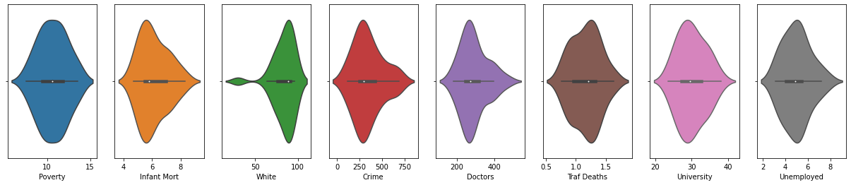

Index(['Alabama', 'Arizona', 'Arkansas', 'Florida', 'Georgia', 'Idaho',

'Indiana', 'Kentucky', 'Louisiana', 'Michigan', 'Mississippi',

'Missouri', 'Montana', 'Nevada', 'New Mexico', 'North Carolina', 'Ohio',

'Oklahoma', 'South Carolina', 'South Dakota', 'Tennessee', 'Texas',

'West Virginia'],

dtype='object', name='States')

